Recycling Machine System

M. Qasim
16053

Class Diagram
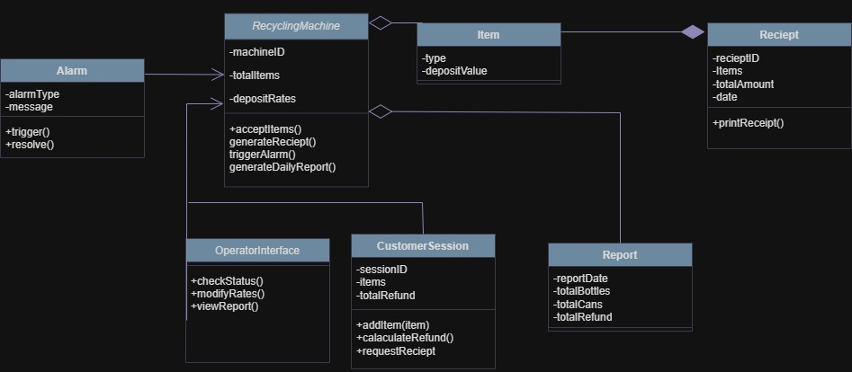

CODE:
/***********************************************************************
* Module: RecyclingSystem
***********************************************************************/

using System;
using System.Collections.Generic;
using System.Linq; // Added for .Sum() in CalculateRefund

namespace RecyclingSystem
{
/// <summary>
/// Represents an error or alert state in the machine.
/// </summary>
public class Alarm
{
// Attributes
public string AlarmType { get; set; }
public string Message { get; set; }

// Operations
public void Trigger()
{
// Implementation for activating the alarm state
}

public void Resolve()
{
// Implementation for clearing the alarm state
}
}

/// <summary>
/// Represents a recyclable item deposited by the customer.
/// </summary>
public class Item
{
// Attributes
public string Type { get; set; }
public double DepositValue { get; set; }

// Constructor
public Item(string type, double depositValue)
{
Type = type;
DepositValue = depositValue;
}
}

/// <summary>
/// Document generated at the end of a customer session.
/// </summary>
public class Reciept
{
// Attributes
public string RecieptID { get; set; }
public List<Item> Items { get; set; } = new List<Item>(); // Association with Item
public double TotalAmount { get; set; }
public DateTime Date { get; set; }

// Operations
public void PrintReciept()
{
// Implementation for printing the receipt data
}
}

/// <summary>
/// Summary of the machine's activity over a period (e.g., daily).
/// </summary>
public class Report
{
// Attributes
public DateTime ReportDate { get; set; }
public int TotalBottles { get; set; }
public int TotalCans { get; set; }
public double TotalRefund { get; set; }

// Operations
public double CalaculateRefund()
{
// Implementation for calculating the refund total for the report period
return TotalRefund;
}
}

/// <summary>
/// Interface for machine personnel to manage the system.
/// </summary>
public class OperatorInterface
{
// Operations
public void CheckStatus()
{
// Implementation to view machine diagnostics
}

public void ModifyRates()
{
// Implementation to update deposit rates
}

public void ViewReport()
{
// Implementation to display a machine report
}
}

/// <summary>
/// Represents a single interaction session with a customer.
/// </summary>
public class CustomerSession
{
// Attributes
public string SessionID { get; set; }
public List<Item> Items { get; set; } = new List<Item>(); // Association with Item
public double TotalRefund { get; set; }

// Operations
public void AddItem(Item item)
{
Items.Add(item);
}

public double CalaculateRefund()
{
TotalRefund = Items.Sum(i => i.DepositValue);
return TotalRefund;
}

public Reciept RequestReciept()
{
// Implementation to initiate receipt creation
return new Reciept();
}
}

/// <summary>
/// The core entity representing the recycling machine.
/// </summary>
public class RecyclingMachine
{
// Attributes
public string MachineID { get; set; }
public int TotalItems { get; private set; }
public Dictionary<string, double> DepositRates { get; set; } = new Dictionary<string, double>();

// Relationships (Associations/Composition)
private Alarm currentAlarm;
public OperatorInterface OperatorInterface { get; set; } = new OperatorInterface();

// Operations
public void AcceptItems(CustomerSession session)
{
// Implementation for processing items from a session
TotalItems += session.Items.Count;
}

public Reciept GenerateReciept(CustomerSession session)
{
// Implementation for creating the receipt object
return session.RequestReciept();
}

public void TriggerAlarm(string type, string message)
{
// Implementation for creating and invoking an Alarm
currentAlarm = new Alarm { AlarmType = type, Message = message };
currentAlarm.Trigger();
}

public Report GenerateDailyReport()
{
// Implementation for compiling and creating a Report
return new Report { ReportDate = DateTime.Today };
}
}
}

